This form should be completed before your appointment to assess with your dietetic assessmenrt.

Personal

Information

Name

Date Of Birth

 |  |  |  |  |  |  |  | Tel/mobile
 |  |  |  |  |  |  |  | Email
 | PRE-ASSESSMENT
 | QUESTIONAIRE |  |  |  |  |  |  | Address
Gender |  |  |  | Height (cm) |  |  |  | Town
 |  |  |  | Weight (kg) |  |  |  | County
 | Emergency contact |  |  |  |  |  |  |  |  | Tel/mobile

Medicines & Allergy informtion

Do you have any allergies?

If yes, briefly outline in the space below

Let's find out a bit of background

Are you being treated any medicines, herbals or other therapies precribed by a Doctor, another practioner or purchased by yourself?

If yes, briefly outline in the space below

Occupation

Current sports & pastimes

Previous occupation

(if any)

Current activity level

Normal activity level

Historic activity level

Sports &

pastimes you

used to do

For safety, we'll need to ask you some quick questions about you medical history

Do you have, suffer from or are you ........

High or low blood pressure?

A problem with bleeding or blood clots?

(including bruising or a stroke)

Any skin conditions or reactions?

(including reactions to metals in jewellery)

Osteoporosis or brittle bones?

Asthma, Emphysema, COPD or Bronchitis?

Arthritis?

Pregnant?

Cancer or a blood disorder?

Stress or anxiety?

Can you give us a bit of information on why you're visiting us?

Tell us, in your own words, what the problem is?

How much does it affect you (0-10)?

Abnormal pain?

(Either now or in the past)

If yes, can you tell us a bit more

Have you had any surgery in the past year?

(including dental work)

(If yes, please tell us a bit more about it)

Do you have a condition not covered by the above? (Please use the box below)

How long ago did it start?

Can you remember what you were or had been doing?

Was it something different to normal?

Does it stop you doing anything you would normally do?

(Please summarise below)
How bad is the pain/discomfort (0-10)?

Can you describe the pain/discomfort?

Please mark the on the chart below where the problem is
Have you tried anything or seen anyone else for the problem?

And finally........

What outcome from treatment would you hope for?

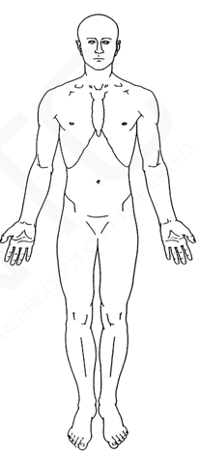

Signature: Date:

(Patient/Guardian)

